# Answers to Questions from TT 6.1

Name: Nguyen Thi Thanh Minh

Student ID: 104169617

**Hand execution using a trace table**

*Demonstrate how the following code is executed in the computer.*

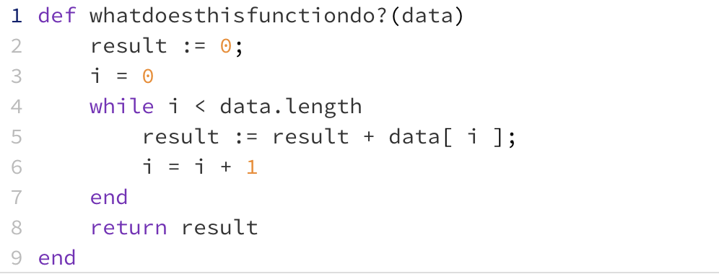

Draw and complete a trace table for the following two sets of data and place the final result in the table below:

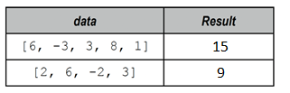

**Once you have completed your trace tables (below) write the name you chose for the function above:**

* I think it should be named *algebraic_sum(data)*, because it sums up all the data values taking account of their signs (adds when the number is positive, and substracts when negative).

**Place your trace tables below:**

For data set: [6, -3, 3, 8, 1]

|  |  |  |  |
| --- | --- | --- | --- |
| **data.length** | **i** | **data[i]** | **result** |
| 5 | 0 | 6 | 0 |
|  | 1 | -3 | 6 |
|  | 2 | 3 | 3 |
|  | 3 | 8 | 6 |
|  | 4 | 1 | 14 |
|  | 5 | nil | 15 |

For data set [2, 6, -2, 3]

|  |  |  |  |
| --- | --- | --- | --- |
| **data.length** | **i** | **data[i]** | **result** |
| 4 | 0 | 2 | 0 |
|  | 1 | 6 | 2 |
|  | 2 | -2 | 8 |
|  | 3 | 3 | 6 |
|  | 4 | nil | 9 |